THORNLIE PRIMARY SCHOOL
LEARNING AT HOME (REMOTE LEARNING)

Dear Parents and Carers,

In 2020 during the COVID 19 lockdown, staff at Thornlie Primary School were able to quickly plan and implement Learning at Home (Remote Learning) programs for students.

This experience has enabled the school to develop a Whole School Response Plan to Learning at Home in preparation for a lockdown.

In the event there is a lockdown announced by the WA Government there are two scenarios that may occur:
- staff are still able to be onsite at the school, or
- staff and students cannot be onsite at the school.

The Whole School Response Plan to Learning at Home will ensure continuity of learning for all students.

For additional information about Learning at Home during a lockdown, please access the Thornlie Primary School Website and read the information within the Response to COVID-19 tab and Learning at Home tab.

We hope these plans will not have to be implemented, however in the event there is a lockdown, it is important that Parents and Carers know that our school has planned and is ready for Learning at Home.

Regards
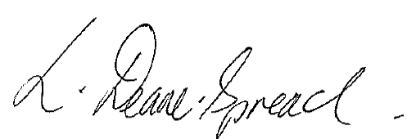

Lynette Deane-Spread
Principal

August 2021.

